**VI. Libre Office**

1. **Create a power point presentation in Libre Office**

**Steps:**

1. **Open libre office Impress**
2. **Select the slide**
3. **Type the necessary contents**
4. **Select animation in Meuu**
   1. **Add animation to the content**
5. **Select slide show to view the slides**
6. **Save the file**

**Output**



1. **Create a chart in libre office calc**

**Steps:**

1. **Open libre office calc**
2. **Insert the subjects and pass percentage data into the cells**
3. **Select the data**
4. **Select insert 🡪 chart**
5. **Select the various options in the chart**
6. **Add a new sheet**
7. **Add the data**
8. **Select insert🡪 chart🡪 pie chart**
9. **Save the file**

**Output**

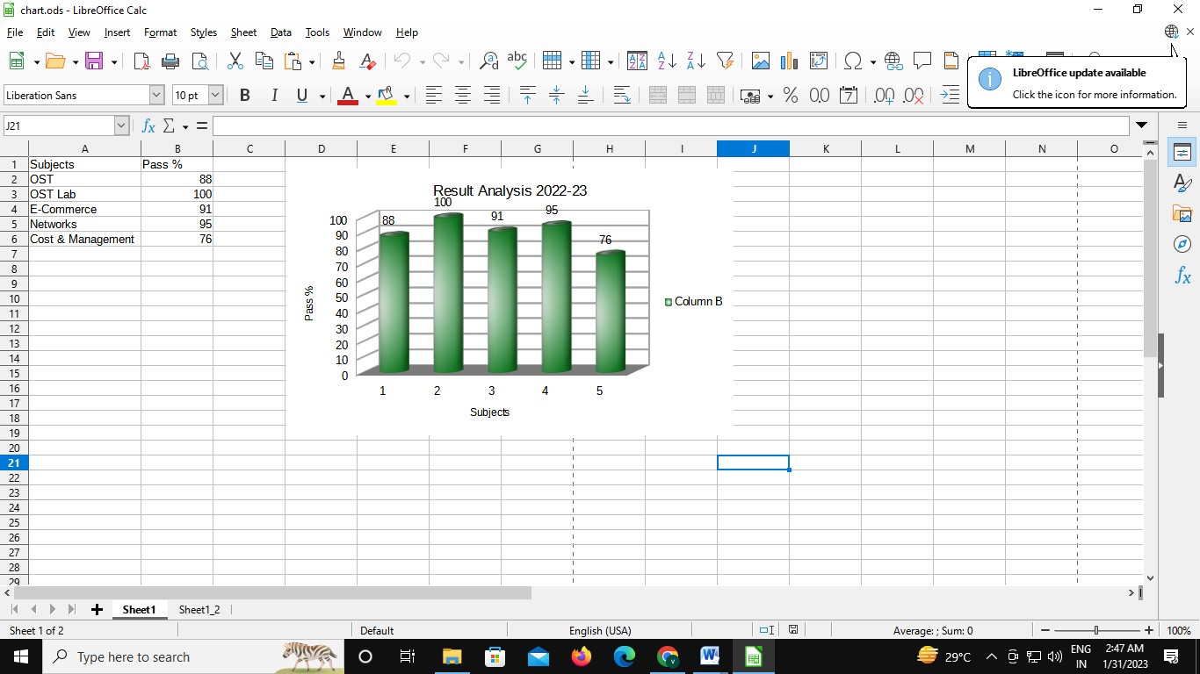

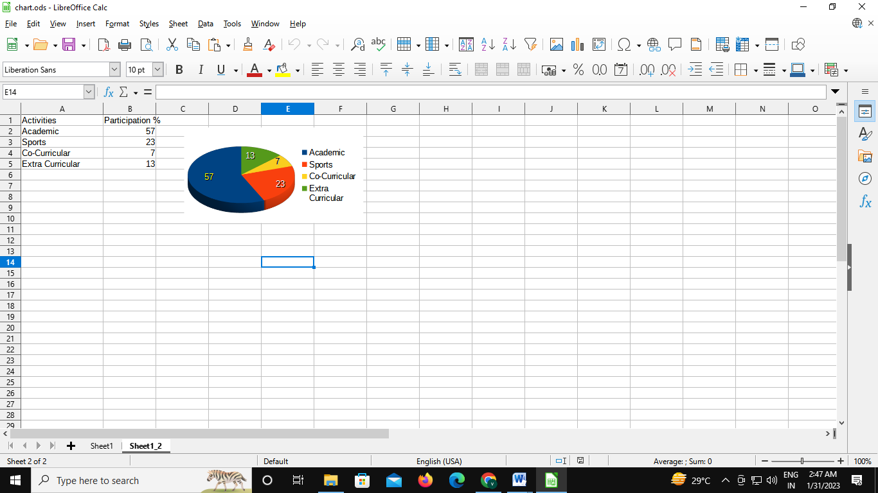

1. **Start LibreOffice Writer, create a new document and type some text in the document. Perform numbering styles in the document using LibreOffice Writer. Save the file**

**Steps:**

1. **Open libre office writer**
2. **Type the data**
3. **Select insert** 🡪 **header and footer** 🡪 **add the header content and footer page no**
4. **Select bullets for sub titles**
5. **Insert the image using insert** 🡪 **image option**
6. **Save the file**

**Output**

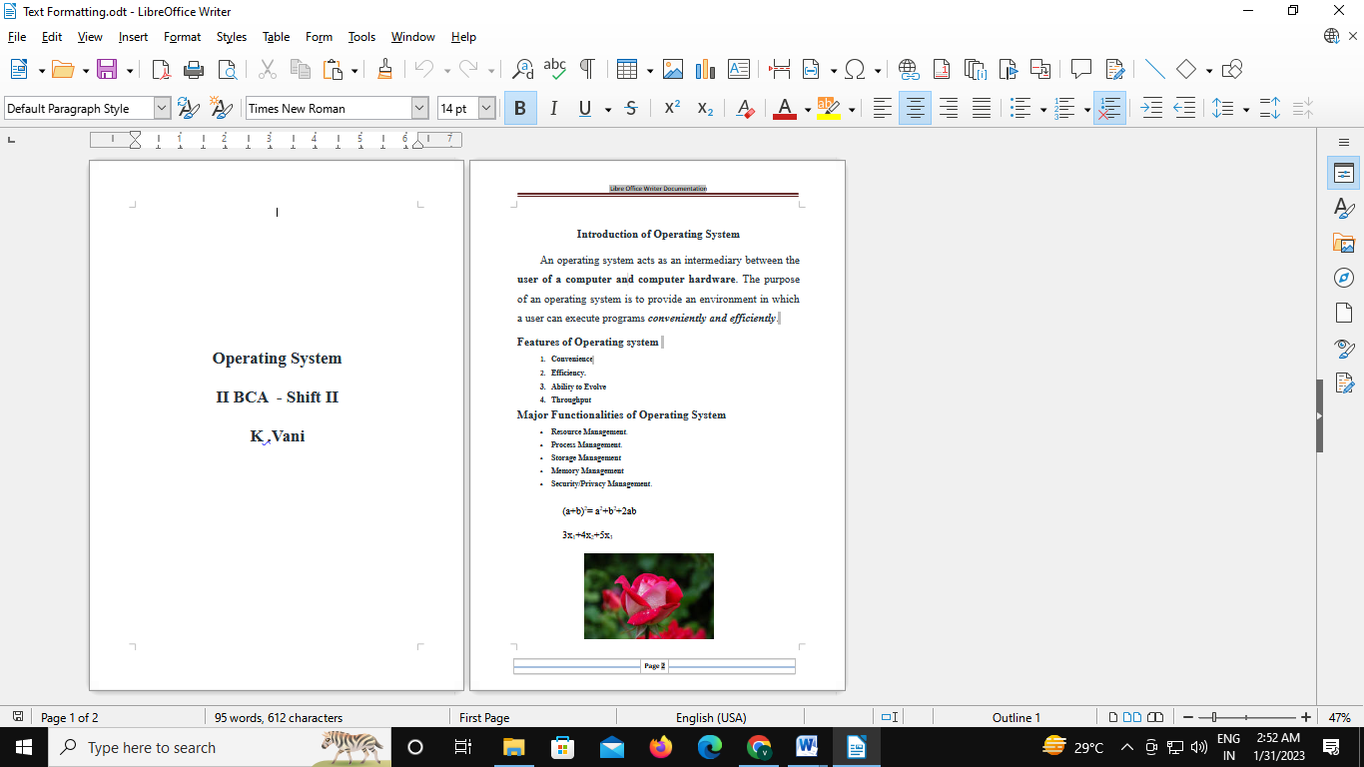

1. **Start LibreOffice Writer, create a new document and type some text in the document. Perform calc basic operations like SUM, AVERAGE, COUNT and MAX. Using LibreOffice Writer. Save the file.**

**Steps:**

1. **Open libre office writer**
2. **Type the data**
3. **Select the column**
4. **Apply the formula =sum(<C2:E2)**
5. **Apply formula for average, minimum, maximum**
6. **Save the file**
7. **Open Libre Office calc**
8. **Enter the data**
9. **Apply the formulas for sum , average, maximum and minimum**
10. **Save the file**

**Output**

